Emerging Distribution Leaders Toolkit

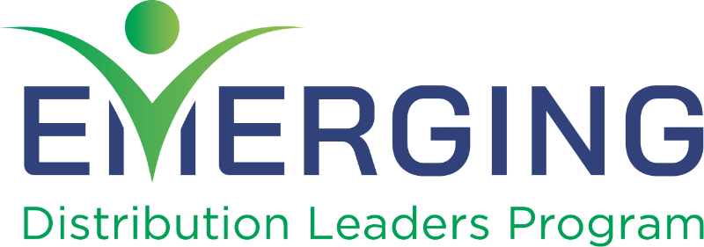

We understand that organizations are always limiting travel and budgets, and we are here to help you develop a strong justification for your boss to send you through the Emerging Distribution Leaders Program. Use the tools in this kit to explain how attending this event is a smart investment in your personal career growth and the operations of your business.

**Focus on the Bottom Line**

When resources are tight, focus on the bottom line by doing a Cost-Benefit Analysis. This worksheet will help you determine the full cost of attendance and identify the benefits you and your organization will gain. Customize the justification letter on the last page to help you draft a formal (and persuasive) request for funding.

Creative solutions can help you get your request approved. Consider these options:

* Before meeting with your supervisor, prepare a plan that shows who will cover your normal duties while you attend the in-person events.
* Offer to prepare and deliver a short presentation and Q&A session for your colleagues to share what you learned. This way, your coworkers will also benefit from your attendance.
* Create a list of potential goals or connections that your business can gain from your participation in the program, to focus on what your business wants to get out of the program.

Please contact [info@nbmda.org](mailto:info@nbmda.org) for questions or support while drafting your request.

**Step 1: Determine the Costs**

Before you can justify your expenses, you need to calculate what they will be. Use this worksheet to estimate the total cost of your attendance.

|  |  |
| --- | --- |
| Expenses all fees listed below are in USD | Cost |
| **Registration Cost**  Includes registration to:   * **University of Innovative Distribution** (individual price= $1,995) * **Master Manager Program** (individual price = $1,000; exclusive offer) * **UID In-a-Day** (individual price = $795) * **NAFCD + NBMDA Annual Convention** (individual price = $1,025) | $3,995 |
| **Travel**  Visit a travel website to estimate your flight and/or transportation costs for the following events:   * ***University of Innovative Distribution***   Indianapolis, IN | March 10-13   * ***NAFCD + NBMDA Annual Convention***   Chicago, IL | November 4-6 | $ |
| **Hotel**  Check out the specific event sites for hotels and group rates:   * [**University of Innovative Distribution**](https://www.univid.org/aws/AEA/pt/sp/UID_hotel) * [**NAFCD + NBMDA Annual Convention**](https://www.distributorconvention.org/Travel-Stay) | $ |
| **Meals**  Use this section to calculate the cost of meals for your trips. Once you get on-site, you will not have to pay an additional fee for food.   * ***University of Innovative Distribution*** * ***NAFCD + NBMDA Annual Convention*** | $ |
| **Total Cost** | $ |

### **Step 2: Outline the Benefits**

When showcasing the benefits of the Emerging Distribution Leaders Program, focus specifically on what benefits you will bring back to your company as a return on their investment. Prep by answering these questions:

* What skills and topics would help your team overcome current or future challenges?
* How can the skills learned in the program improve efficiency in your current role, and future roles?
* What leadership opportunities can I take over to help improve my boss’ life?
* How can networking with other rising leaders in wholesale distribution help you?

When considering these questions, keep these tips in mind:

* List specific benefits of attending the year-long program, and how they will impact you, your organization, and your job.
* Detail the current and future benefits of associating with NBMDA.
* Passion is the best persuasion technique – let yours shine through in your letter.

**Step 3: Draft Your Justification Letter for the 2025 Emerging Distribution Leaders Program**

Below, you will find a Justification Letter template — to help you explain to your supervisor the benefits you will receive from attending EDL workshops, how it will make you a better employee, and helps advance your organization. This general template will get you started while allowing you to customize it to you and your organization's particular needs.

Dear **< approver’s name >**,

I would like to apply for the 2025 cohort of the Emerging Distribution Leader Program and develop my skills as a professional in the distribution industry. To do so, I need your support as my supervisor to sponsor my application.

This initiative is a curated program that focuses on up-and-coming distribution leaders to help us strengthen our management and leadership skills to advance our careers. Through attending this program, I will gain educational insights into the future of the industry, networking opportunities with potential partners, and a direct connection with NBMDA volunteer leadership.

Through dedicated education sessions throughout the year, I will gain managerial techniques that can be actively applied to operations to **< your business >. < give details on specific topics covered that will help your business, with details from** [the website](https://www.nbmda.org/Education-Training/Emerging-Distribution-Leaders) **>.**

**Along with gaining the knowledge necessary for completing the program, I will be in cohort with other mangers in the distribution channel. This invaluable networking opportunities are year-long and will foster deeper connections that can be used for the benefit of < your business >. I will also have opportunities to connect with NBMDA volunteer leadership, whose expertise c which can be passed down to me and < your business >.**

I’m confident that between the managerial skills taught and opportunities to grow my professional network, this program will be a worthwhile investment in both my personal growth and the growth of our company.

I’m requesting **< total amount you need >** for the following expenses:

Registration: **<$xxxx>**  
Travel: **<$xxxx>**

Program applications close March 1, 2025, or until the University of Innovative Distribution registration fills up. Please let me know if you have any questions or would like more information.

Sincerely,

**< your name >**